0000 – <https://app.any.run/tasks/8d6e00af-8061-401f-8e1d-232738b793ff>

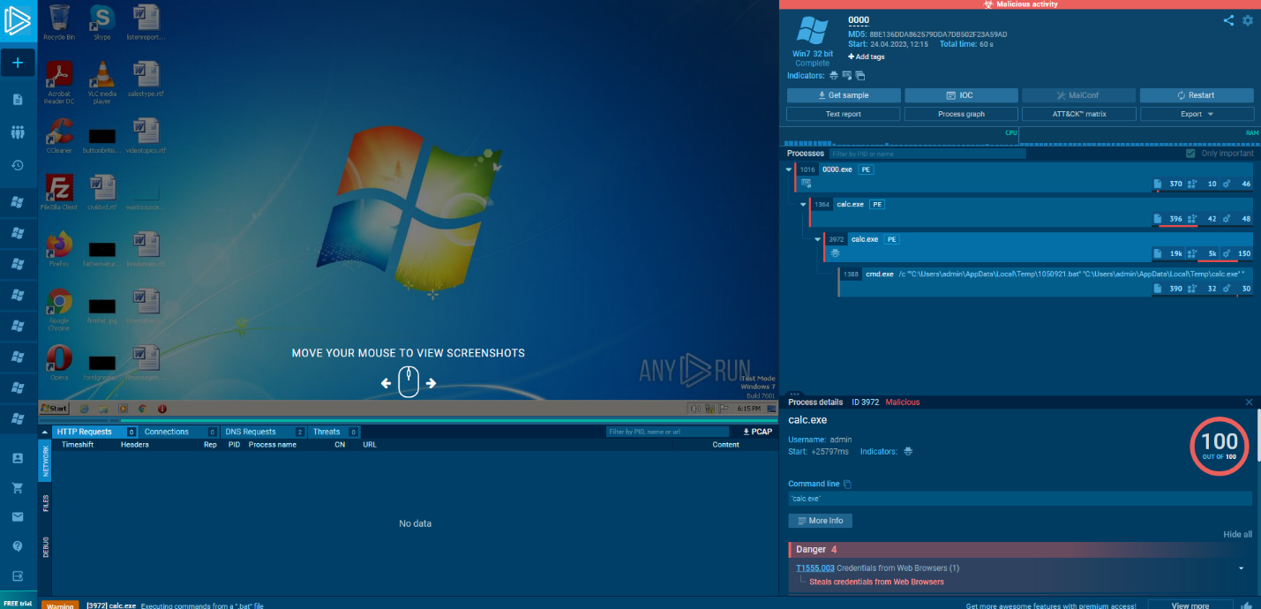

0001 – <https://app.any.run/tasks/01049465-b97d-420b-a76c-facea04d70a9>

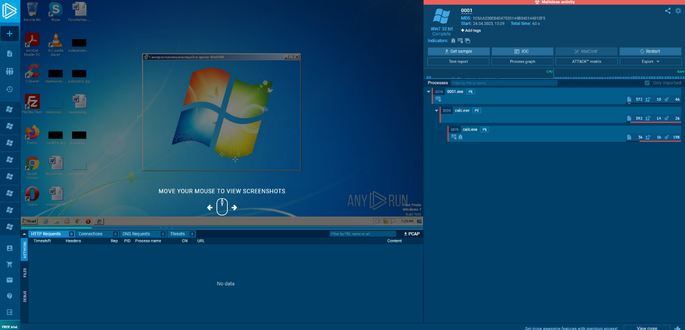

0002 – <https://app.any.run/tasks/92278b0c-c1e4-4e21-b44f-14aabd22013d>

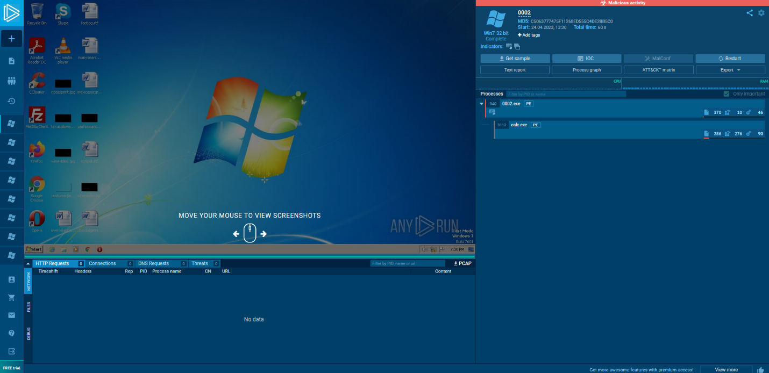

0003 – <https://app.any.run/tasks/40088102-748a-4833-830d-135efe53c4dd>

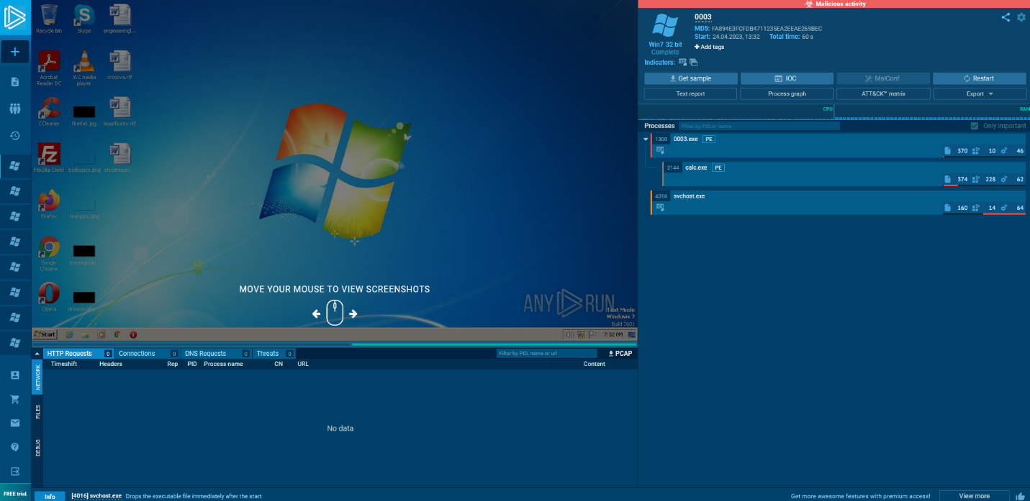

0004 – <https://app.any.run/tasks/65f34116-c803-48d1-a9ca-9e42a79329c4>

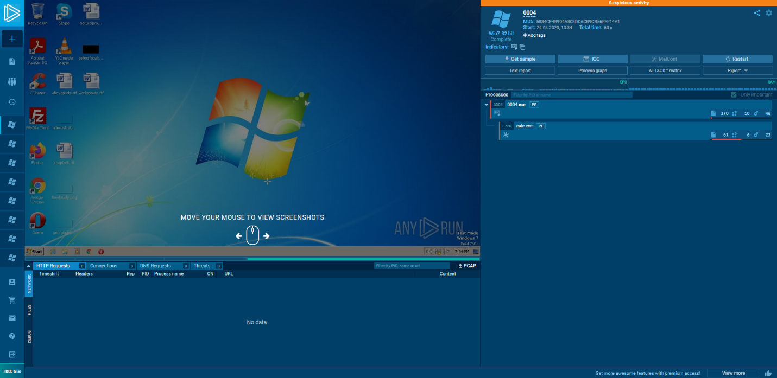

0005 – <https://app.any.run/tasks/cc2a3859-ef1d-498e-9c59-70e053a50f05>

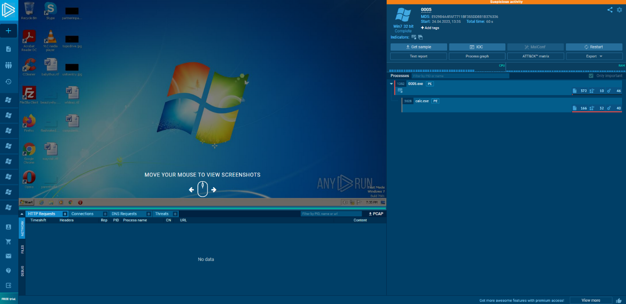

0006 – <https://app.any.run/tasks/6842c040-5ca9-4d5f-b359-f43bf45433ab>

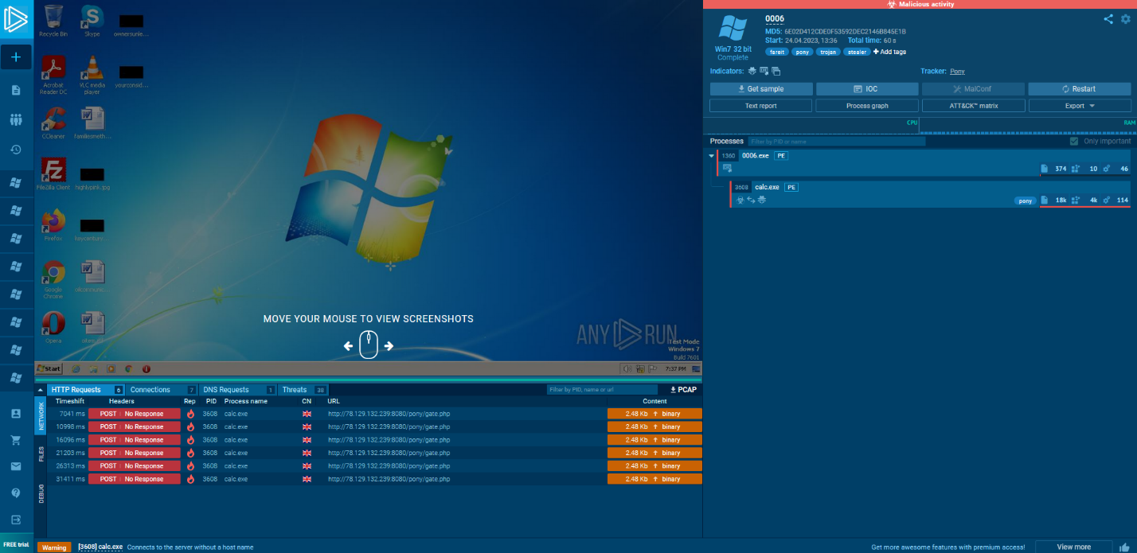

0007 – <https://app.any.run/tasks/f2d6693a-e9e0-44c8-8bf7-6037a78bebea>

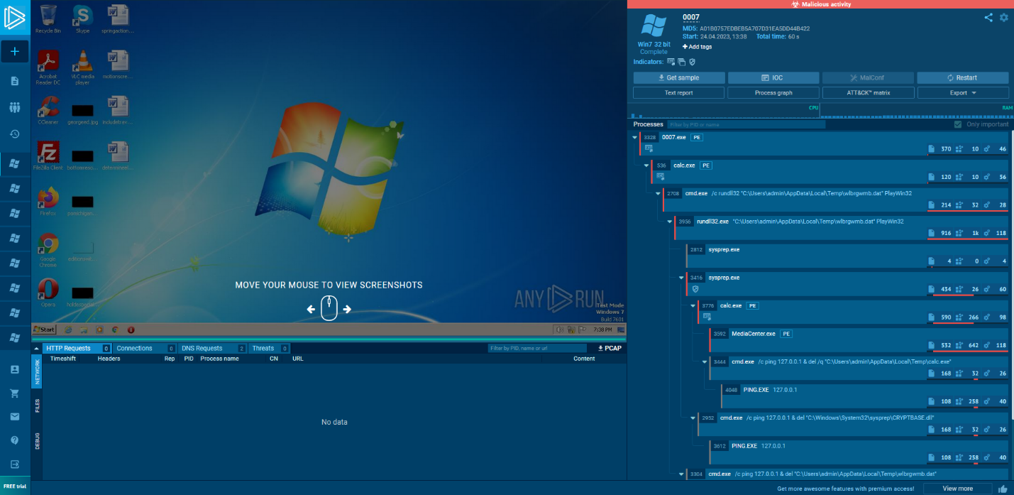

0008 – <https://app.any.run/tasks/a43b56dd-a302-46aa-b95c-95a42e7c6753>

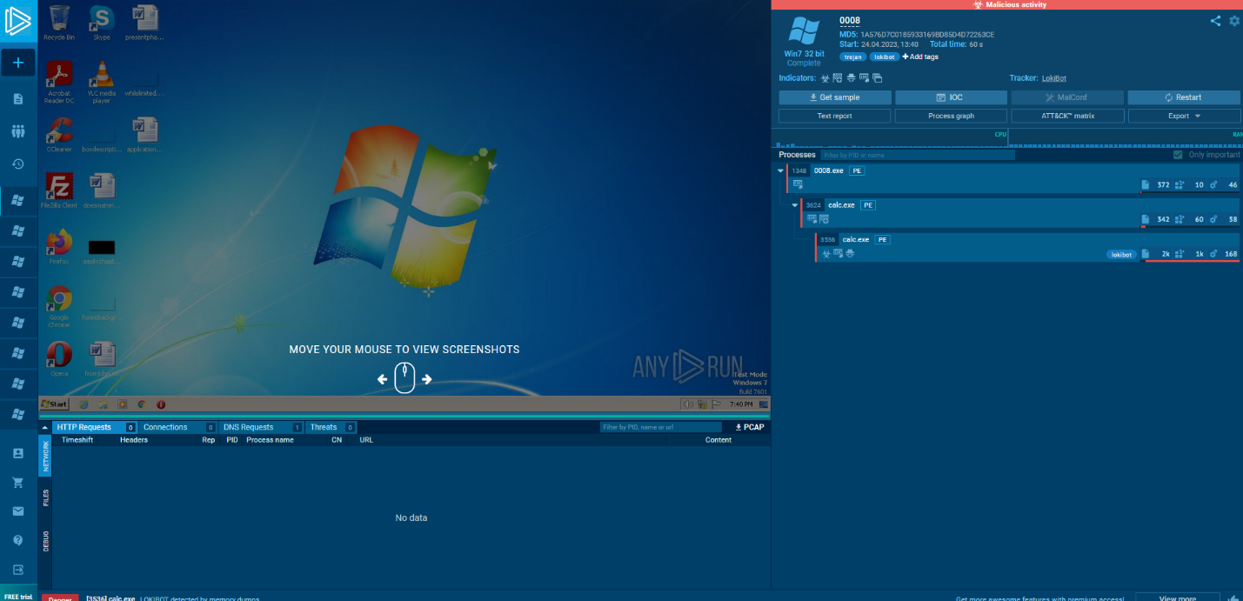

0009 – <https://app.any.run/tasks/947e9c76-0ce9-4ed6-942b-18608d49aa3d>

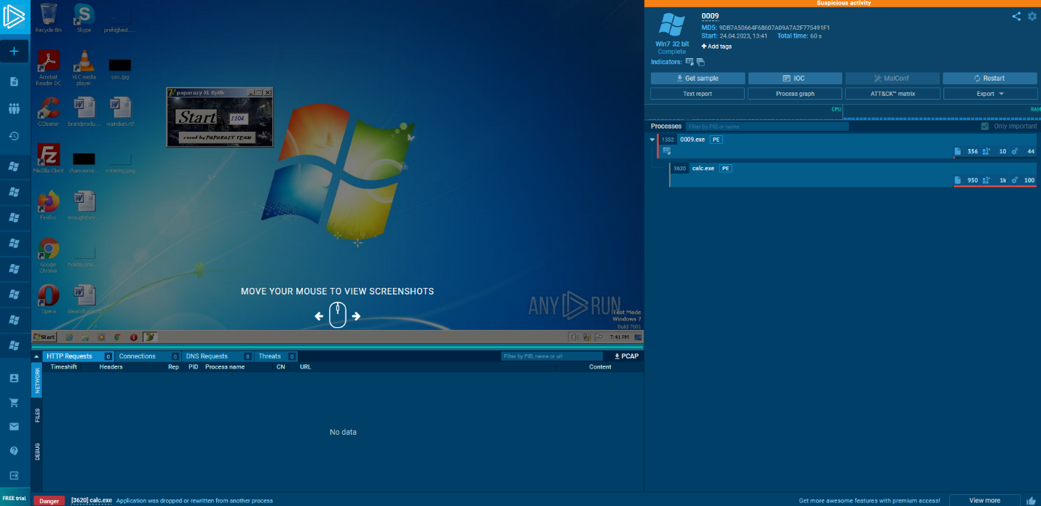

0010 – <https://app.any.run/tasks/381b1f43-ee35-4bf3-b443-2772cc3cda8e>

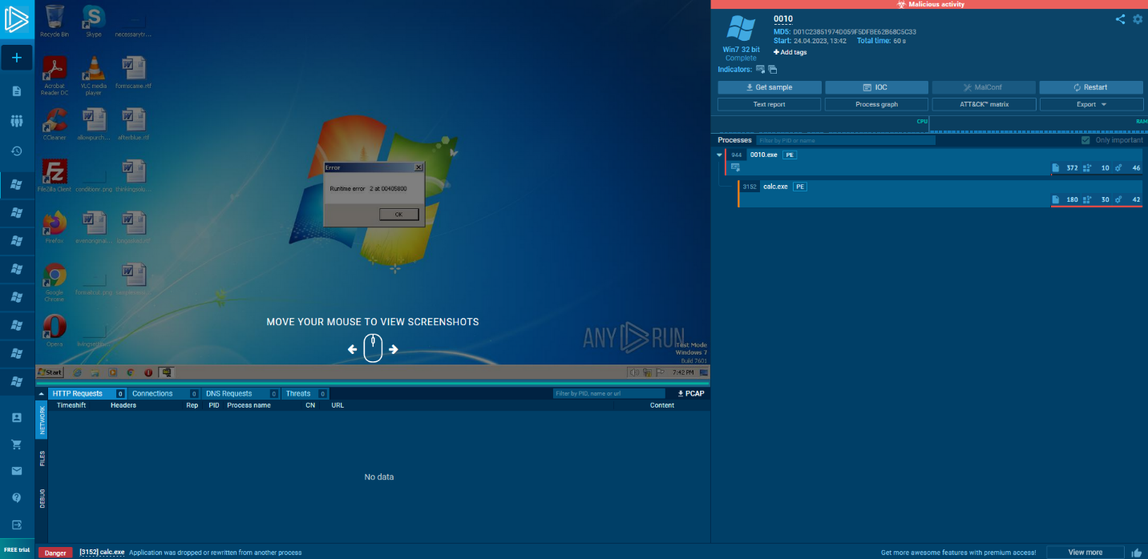

0011 – <https://app.any.run/tasks/2005b4ba-ffb2-433b-b2a7-52310fdce1be>

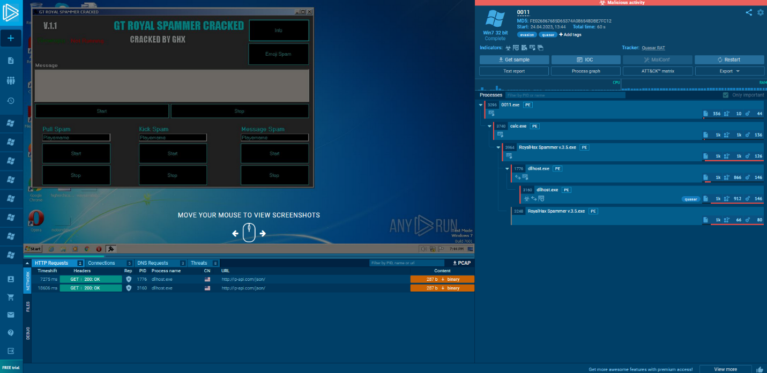

0012 – <https://app.any.run/tasks/e8b42bc8-64b2-49aa-ace8-66c2655b4b2f>

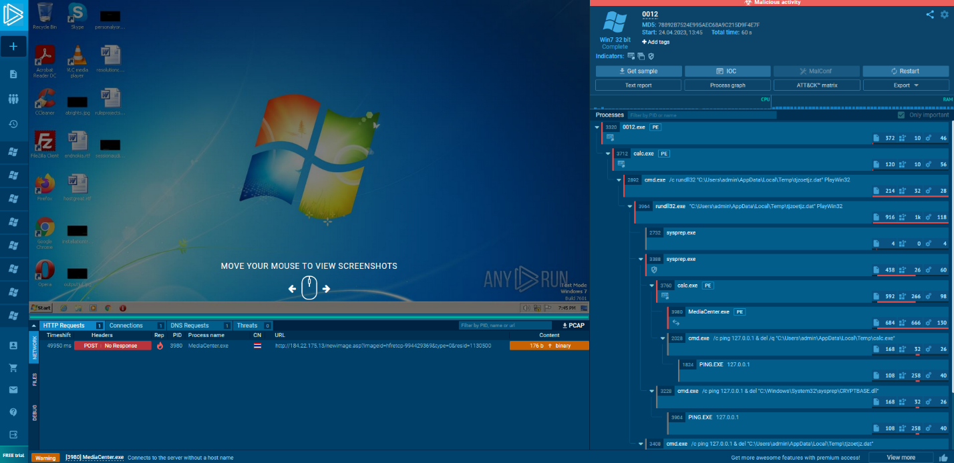

0013 – <https://app.any.run/tasks/bf231e3b-e9ea-4ef7-8be9-ba6cac0d9000>

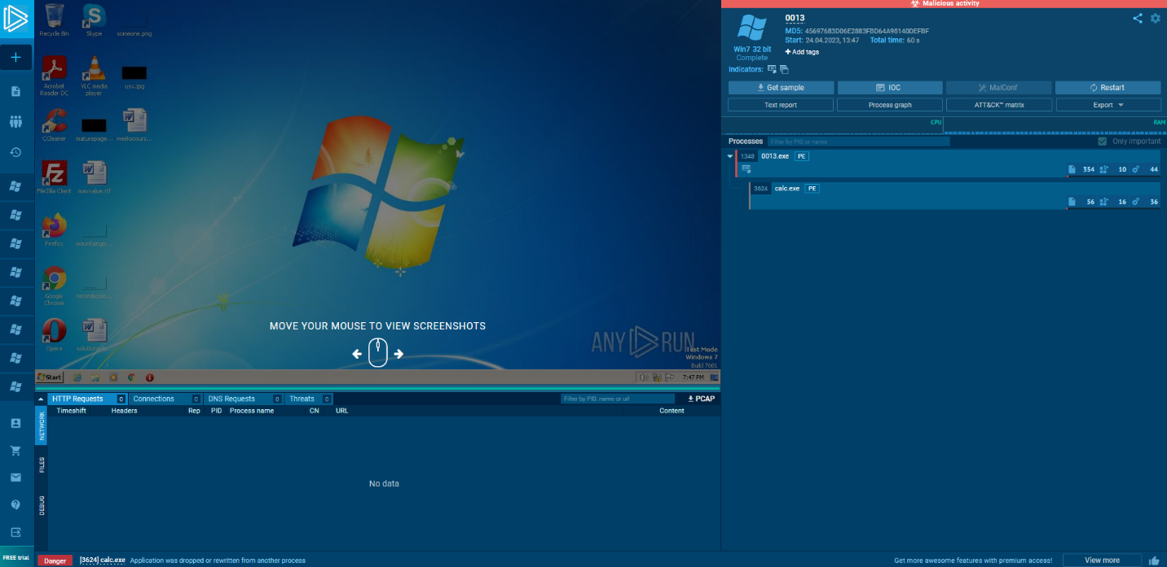

0014 – <https://app.any.run/tasks/687e1fcf-88be-4295-a3d8-a3f6892c7fd0>

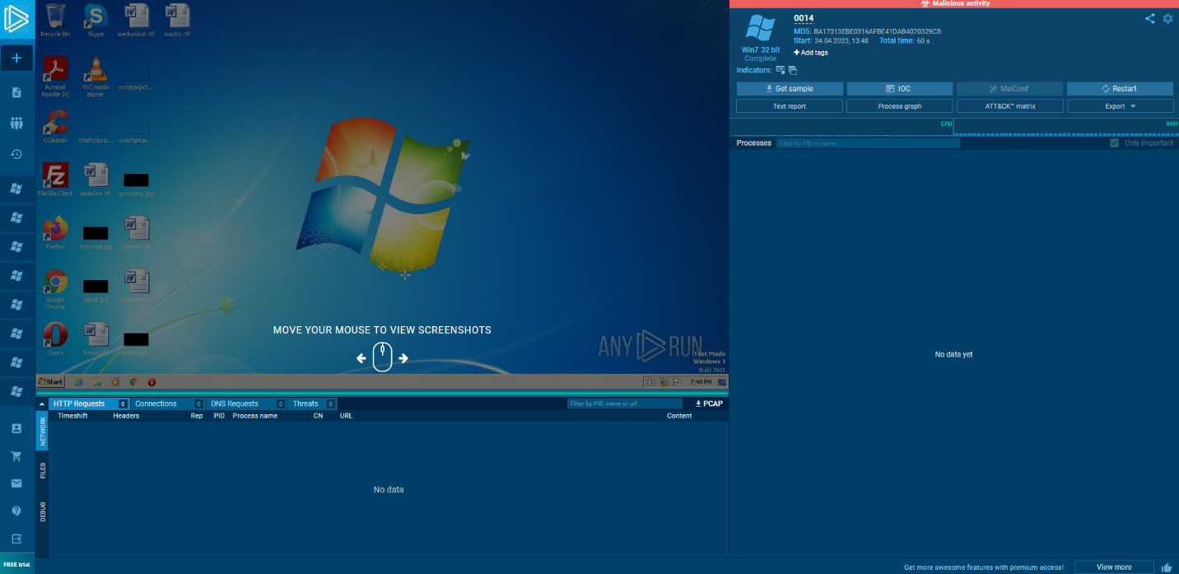

0015 – <https://app.any.run/tasks/38564235-e142-4911-8968-bff2fc78f272>

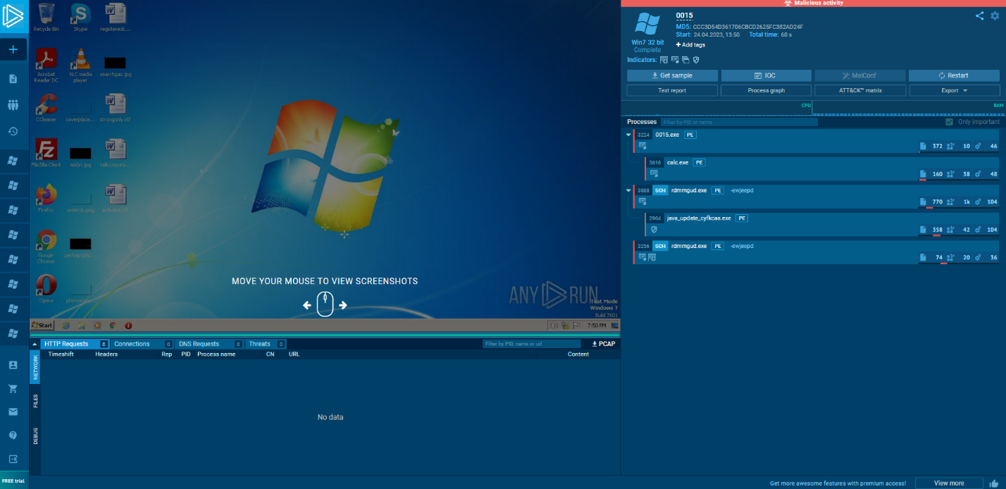

0016 – <https://app.any.run/tasks/d2d7b1fa-c8d3-4611-b12e-1a498e80ab97>

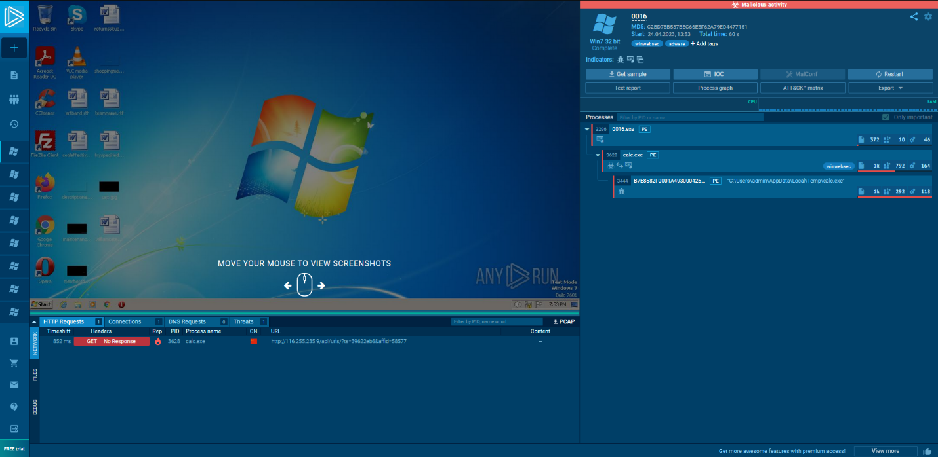

0017 – <https://app.any.run/tasks/2d84b35a-5b66-4d2f-8713-1e69c3f10e7c>

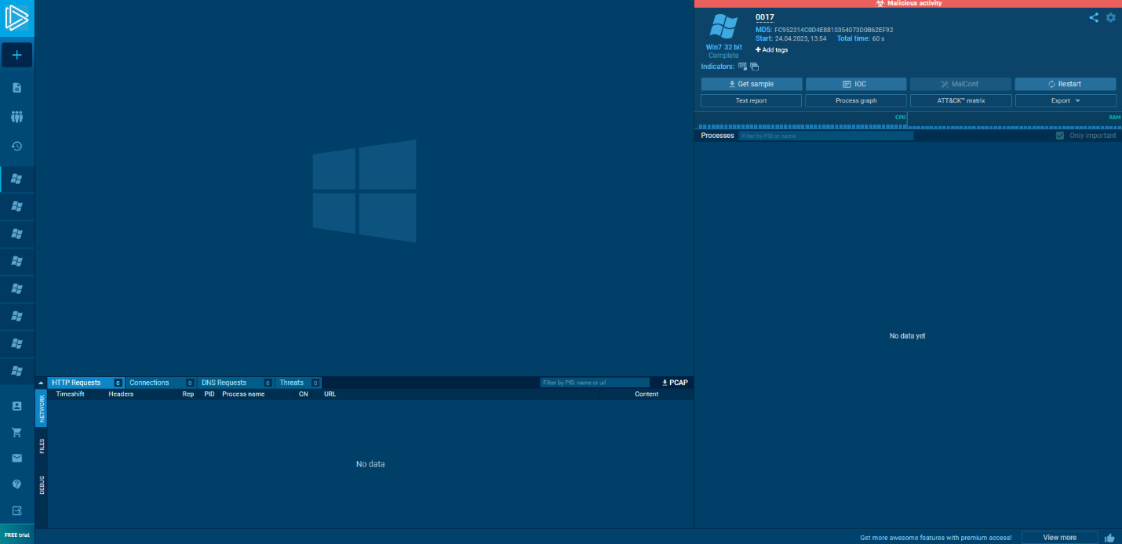

0018 – <https://app.any.run/tasks/df864f7b-643d-4722-aa11-a51648415b03>

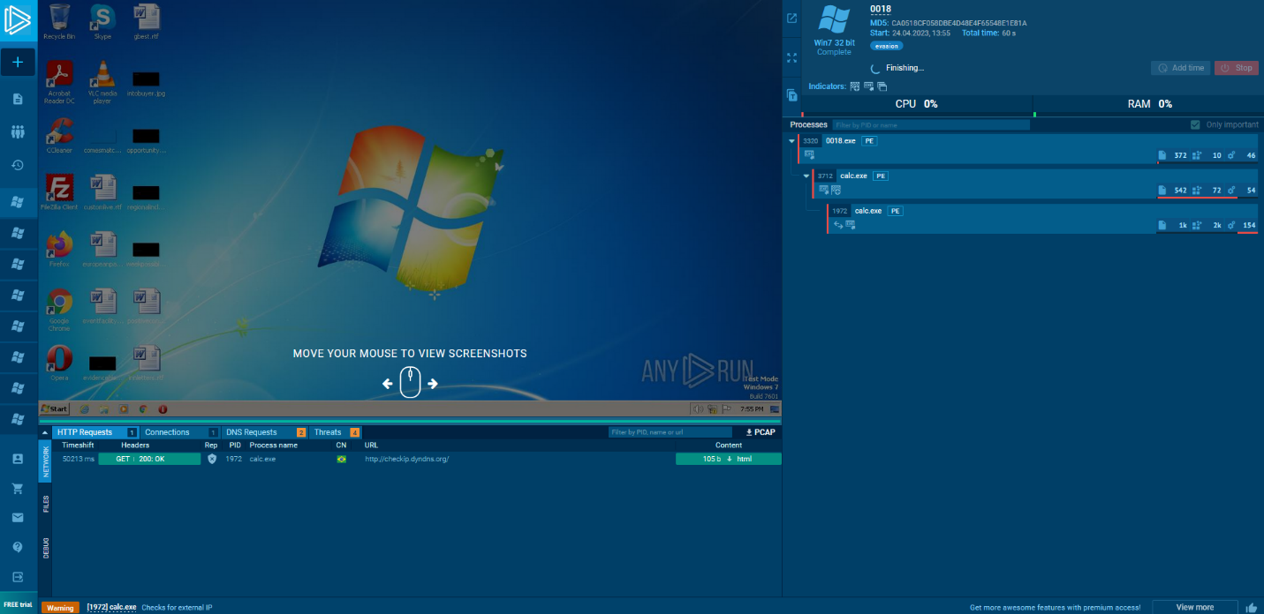

0019 – <https://app.any.run/tasks/939f8779-7e7b-4f4f-9f8d-61b858b182d4>

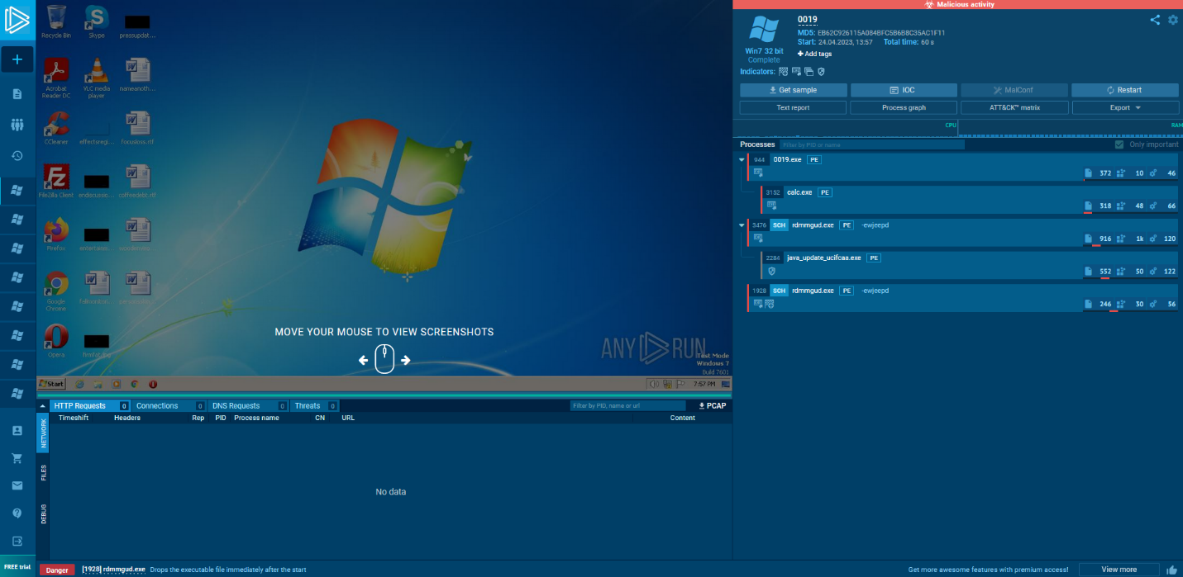

0020 – <https://app.any.run/tasks/9e19f2e7-8c09-400e-a387-94a12a11a798>

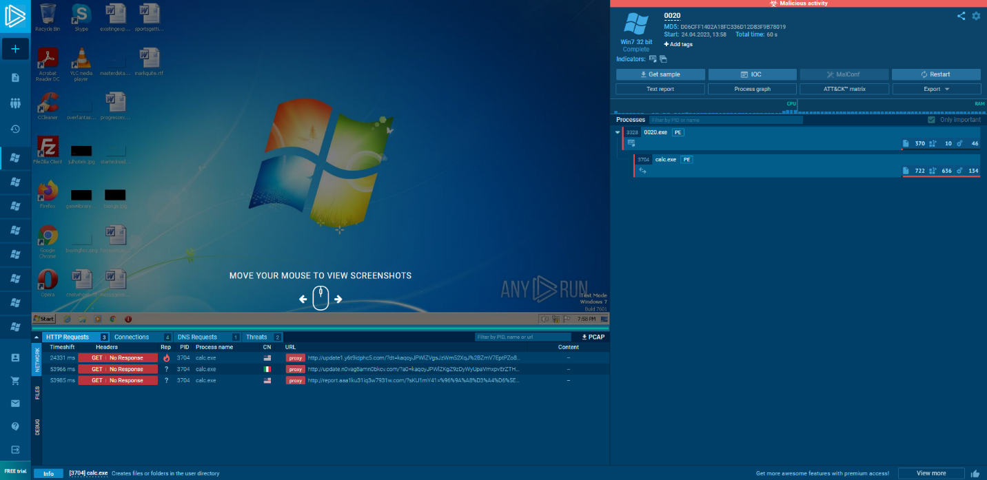

0021 – <https://app.any.run/tasks/088dd74e-3e4f-4da0-af48-8233fc42dddd>

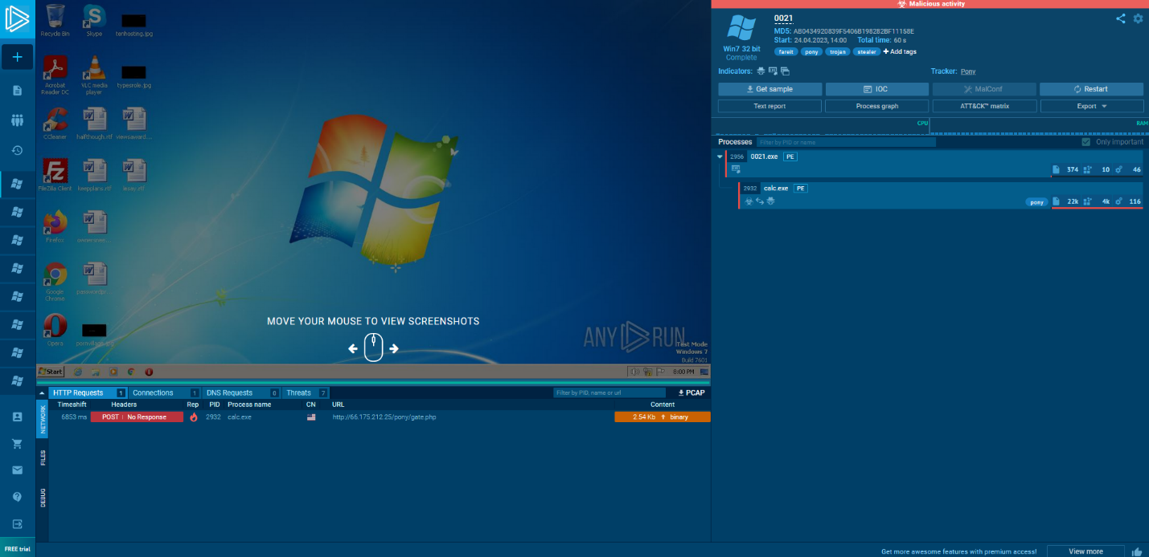

0022 – <https://app.any.run/tasks/df76379e-94e6-4c8e-abca-1fb56774ba19>

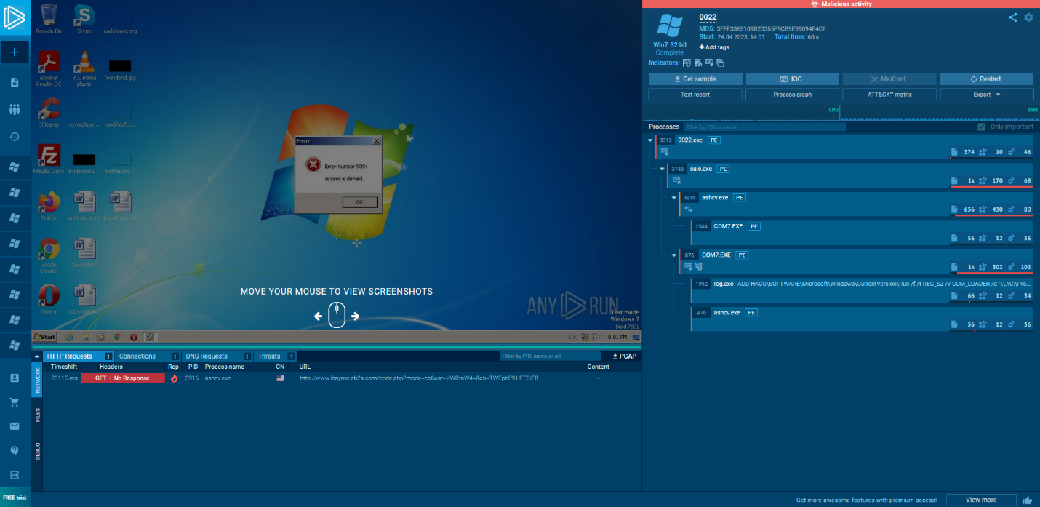

0023 – <https://app.any.run/tasks/c31015dd-79f4-4325-872d-d30e72c160d1>

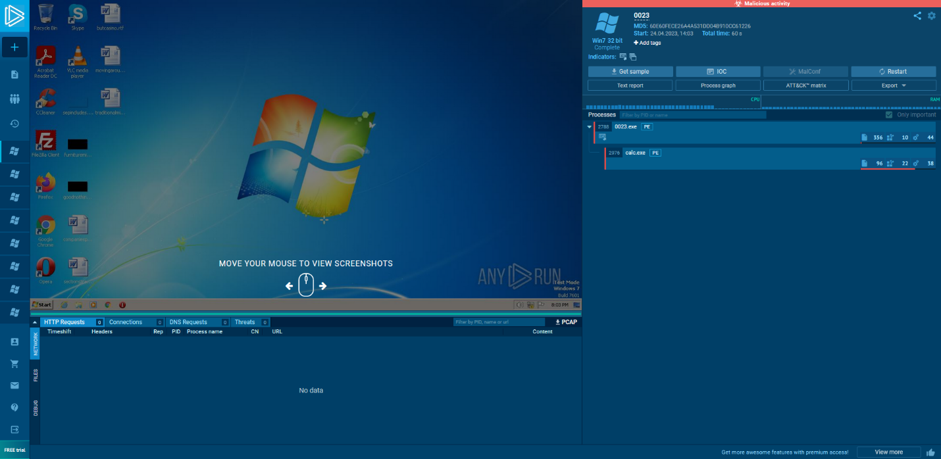

0024 – <https://app.any.run/tasks/27f2cfe4-eed9-44d9-9a12-a1f9ef8b328d>

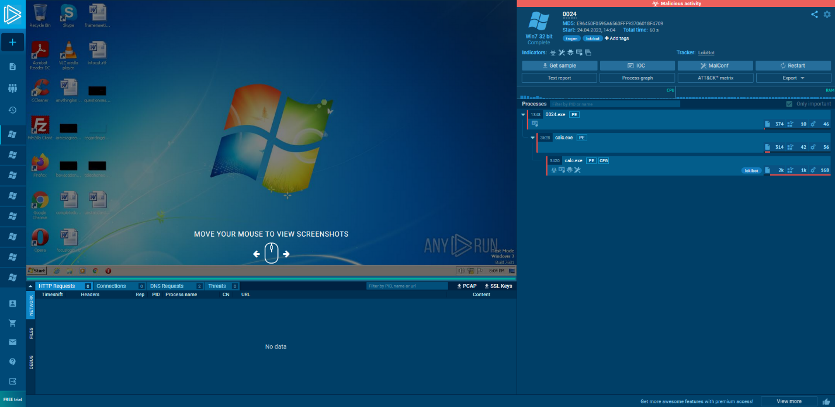

0025 – <https://app.any.run/tasks/35e97a6a-8452-4a0c-91ab-fff0dcbff364/>

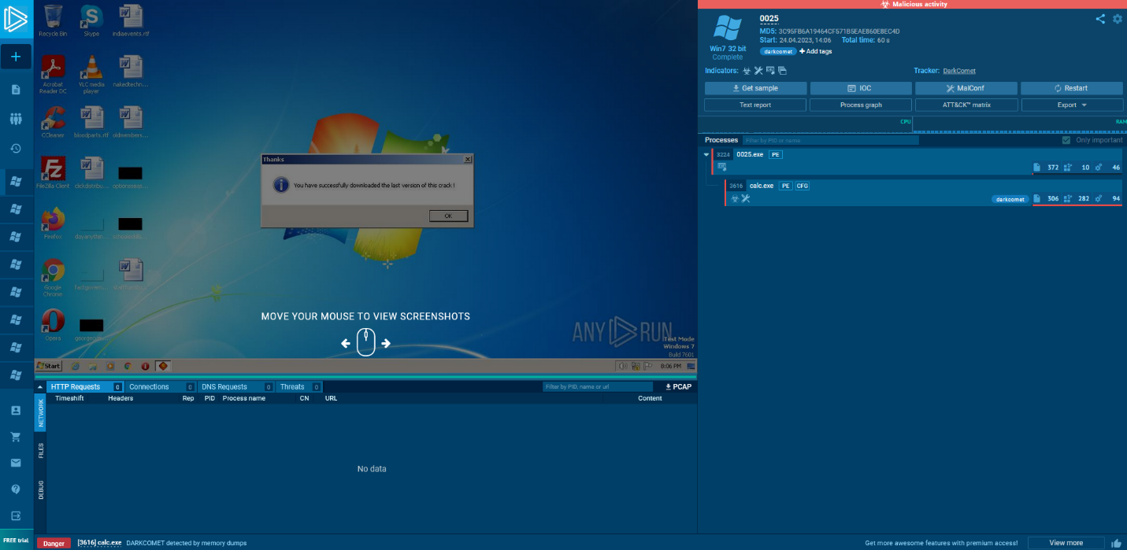

0026 – <https://app.any.run/tasks/3db4d303-bf1d-45b8-b8e0-da7b9371bd6c>

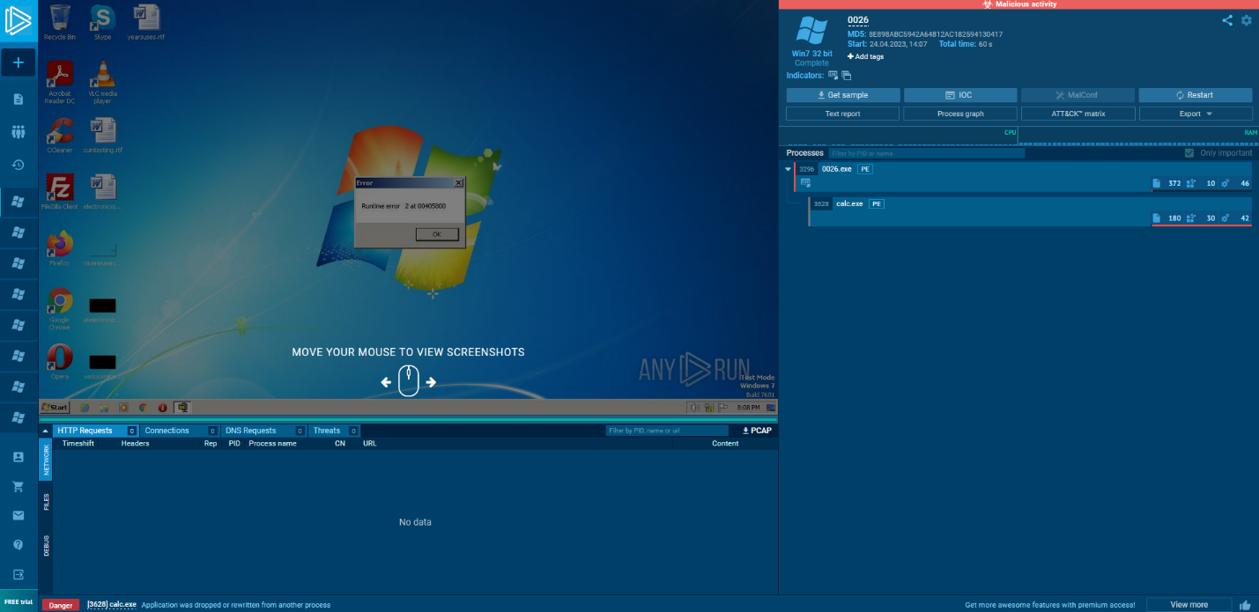

0027 – <https://app.any.run/tasks/e6ae979a-a655-4e74-96d6-9e8f4b61eb16>

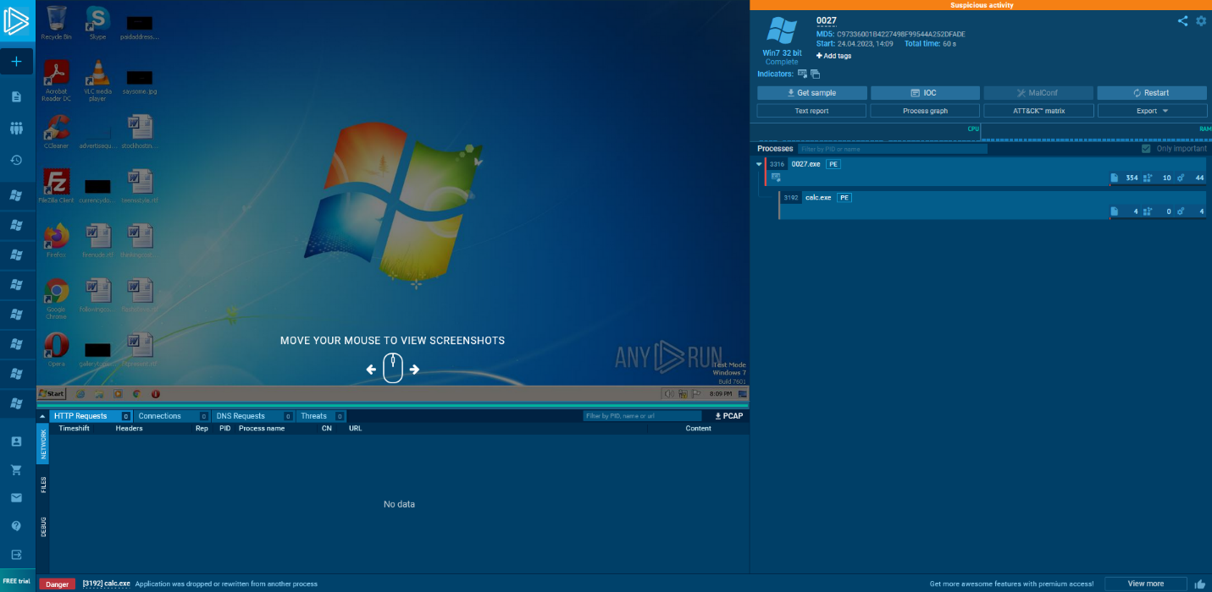

0028 – <https://app.any.run/tasks/6c4a8dbe-adc7-4c9b-8c86-2fe70e409c40>

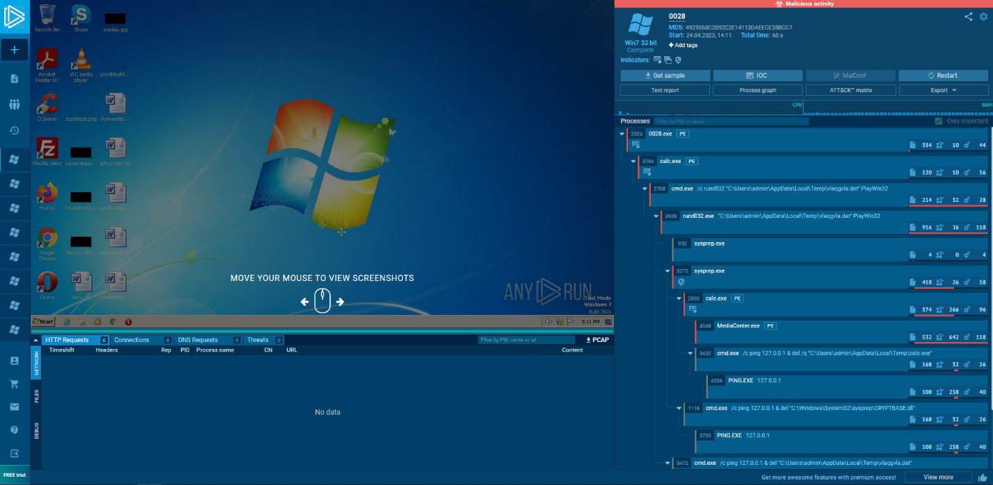

0029 – <https://app.any.run/tasks/21e1f984-71df-445d-b645-3bb3e61f9366>

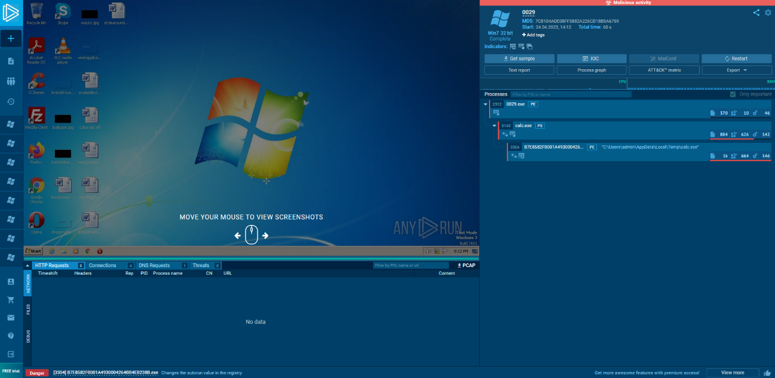

0030 – <https://app.any.run/tasks/14b4f99a-7712-41e9-9e28-96d8f8c2ddd1>

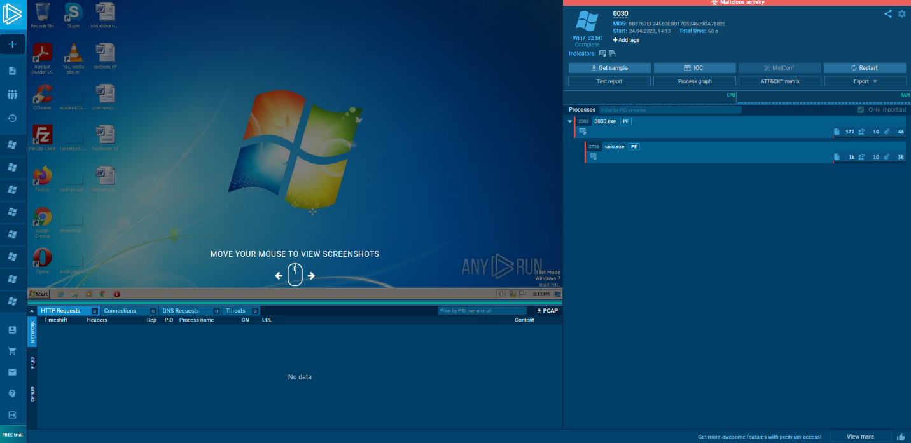

0031 – <https://app.any.run/tasks/1632089c-28c9-473b-b7d0-9dece33412a6>

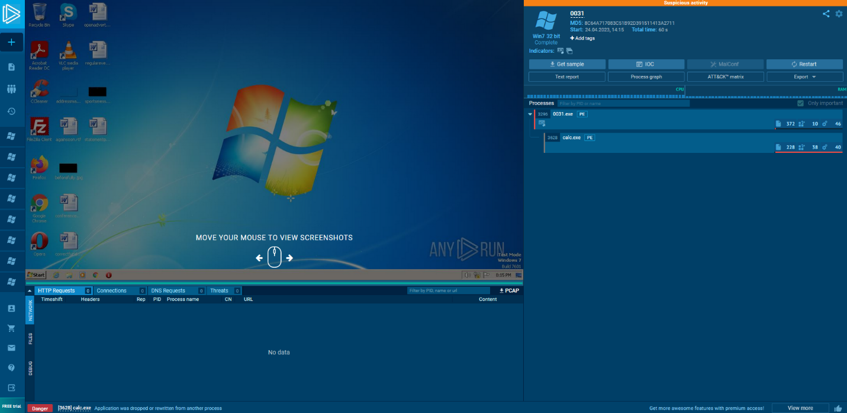

0032 – <https://app.any.run/tasks/abb1d1d3-2452-460a-bb15-7af31cd5905d>

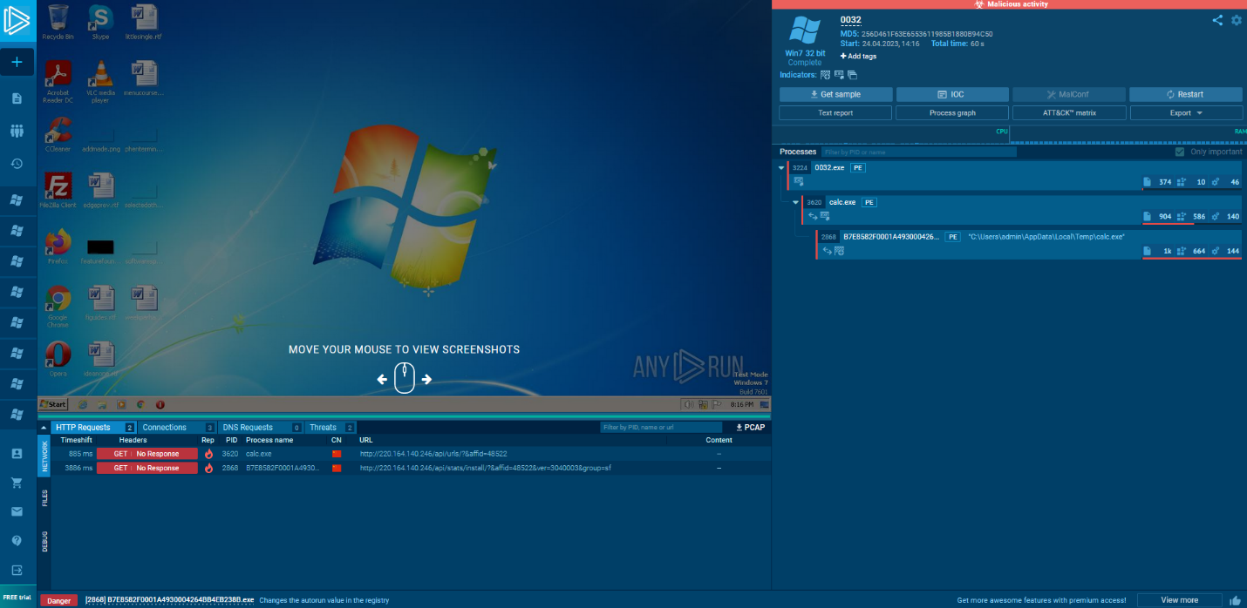

0033 – <https://app.any.run/tasks/f7f6d240-59a2-4340-89e4-a5f89f75066b>

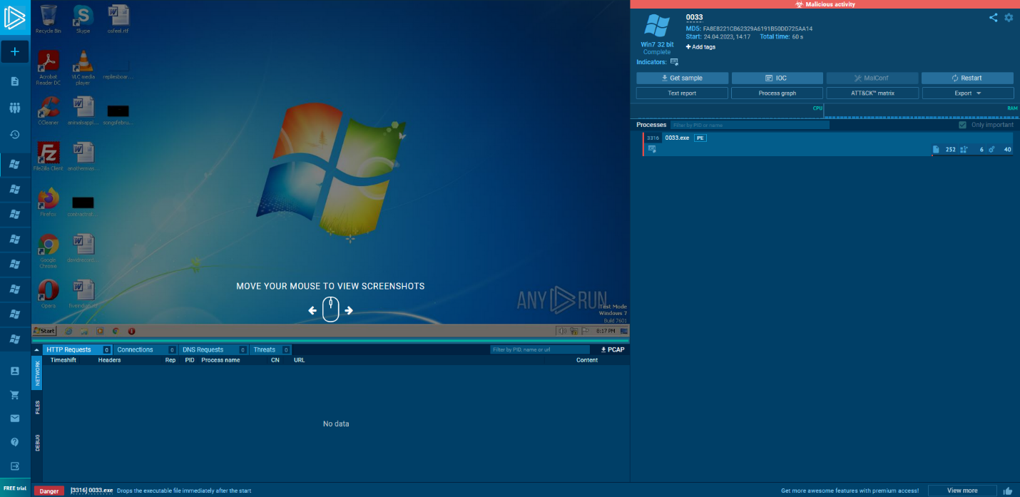

0034 – <https://app.any.run/tasks/f6409a63-d761-43ee-98a0-ef5f9a4afe35>

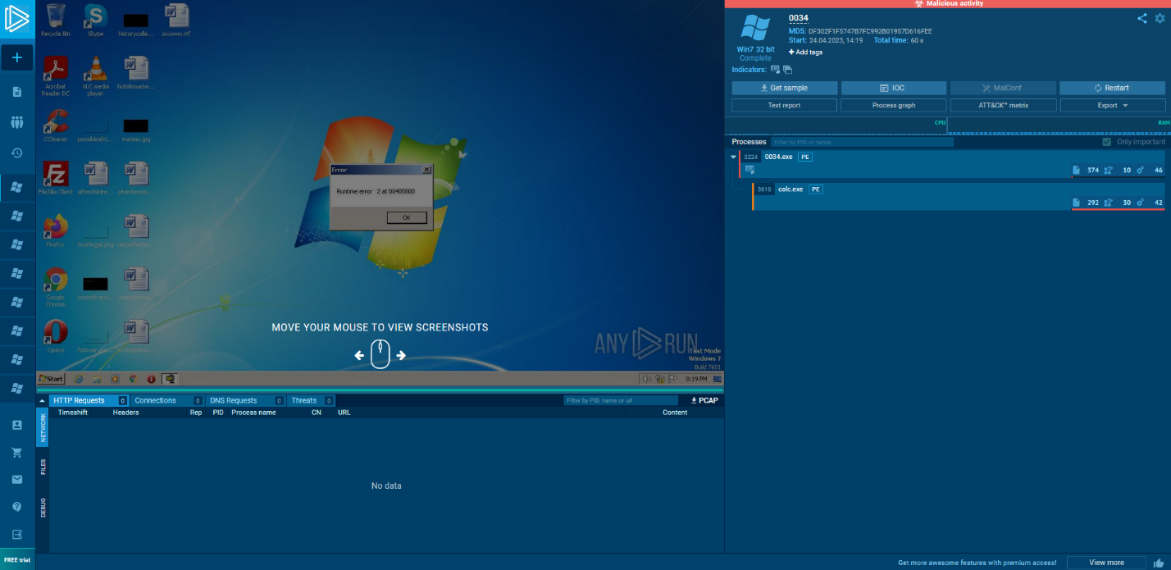

0035 – <https://app.any.run/tasks/b9166d4e-8fb0-43b1-881f-f5093c2cbae1>

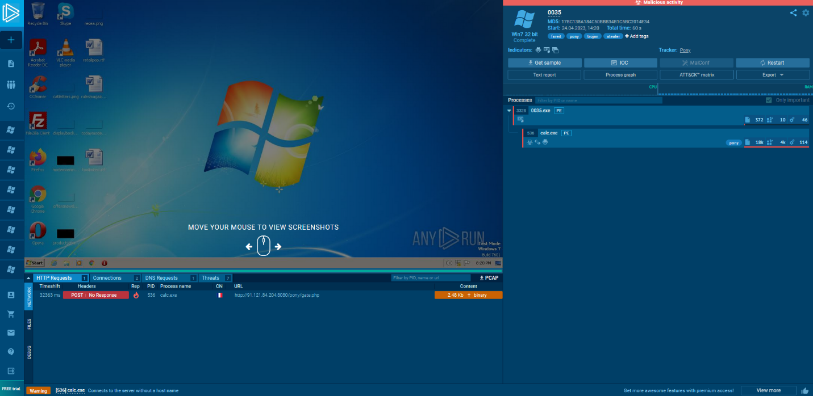

0036 – <https://app.any.run/tasks/90116f31-c618-4dac-ac58-4683440d5d5f>

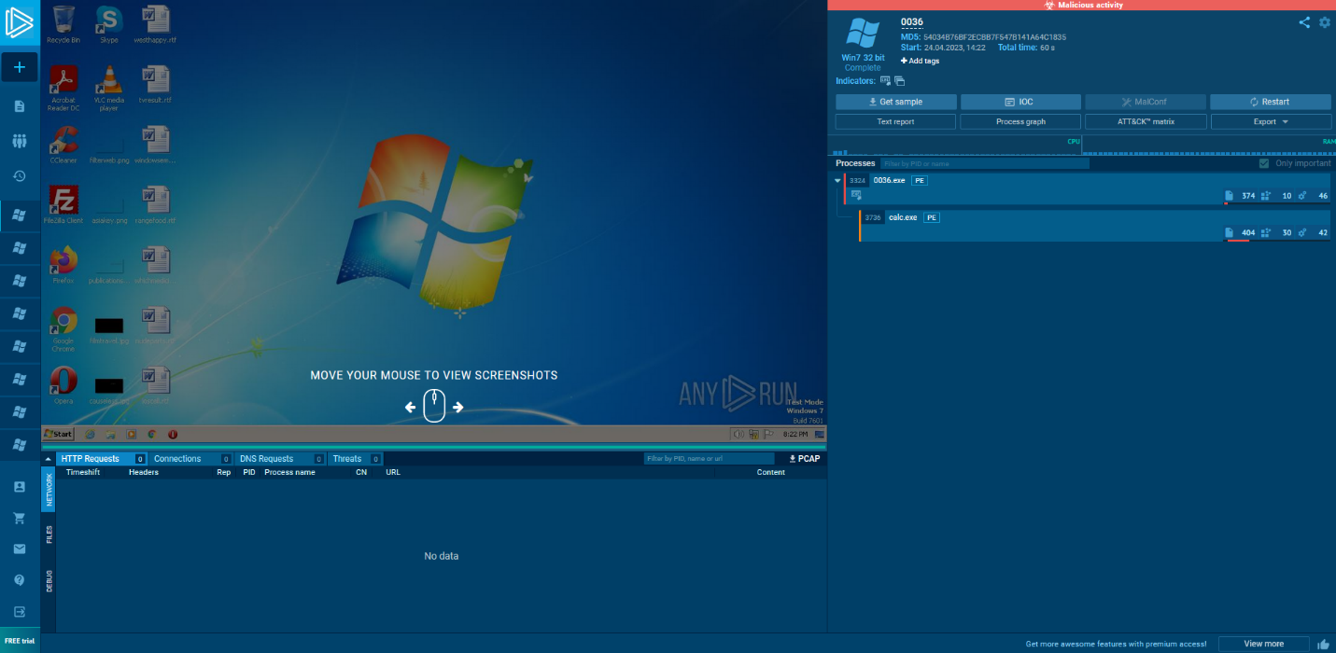

0037 – <https://app.any.run/tasks/8c597687-aca6-4d7e-8052-47161a8d1b55>

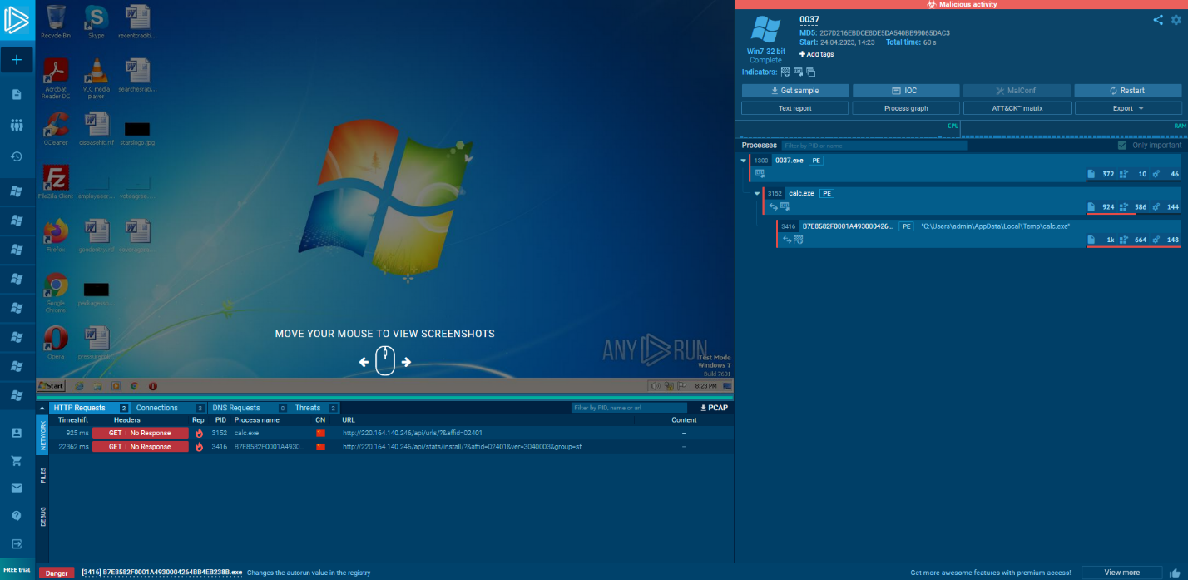

0038 – <https://app.any.run/tasks/f6bbecd2-b82a-4848-aea1-b5f4efea10da>

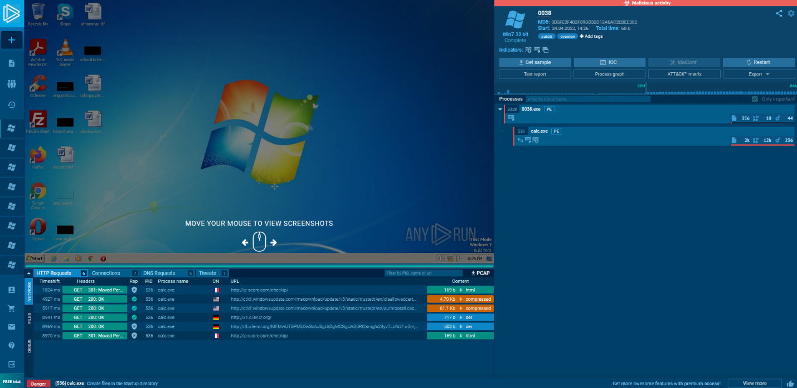

0039 – <https://app.any.run/tasks/858bb58a-766d-4a88-8096-8503b7e9ff6e>

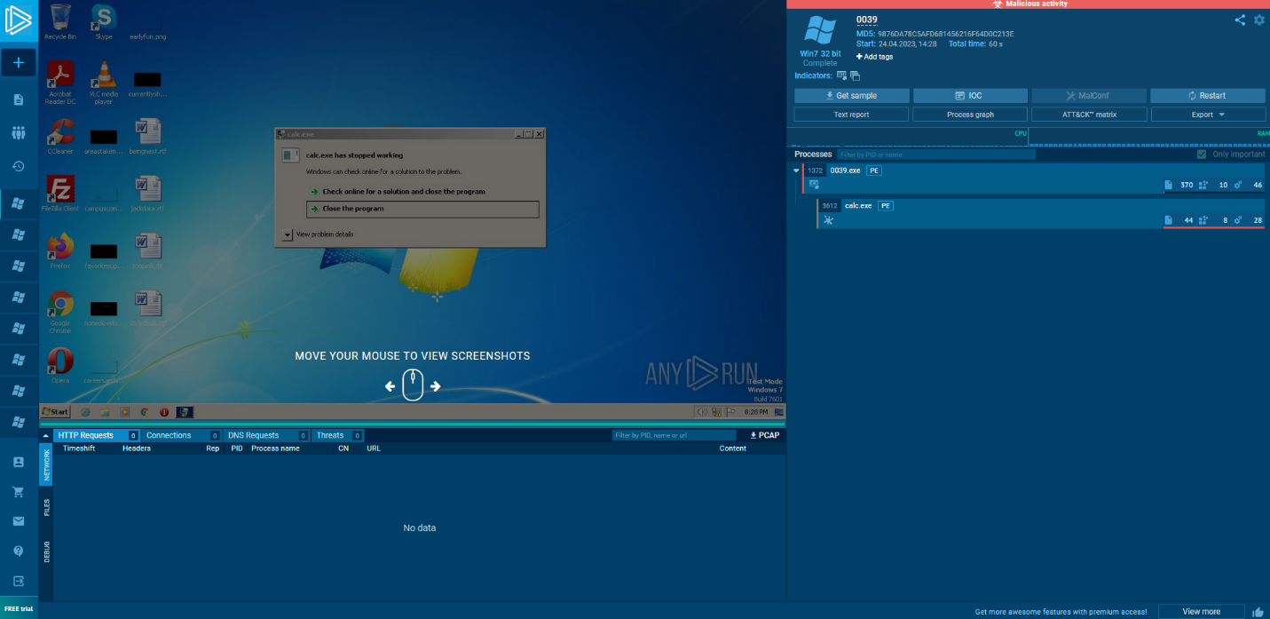

0040 – <https://app.any.run/tasks/6fe0a064-7c8c-4c9f-83ba-b29678fbd07d>

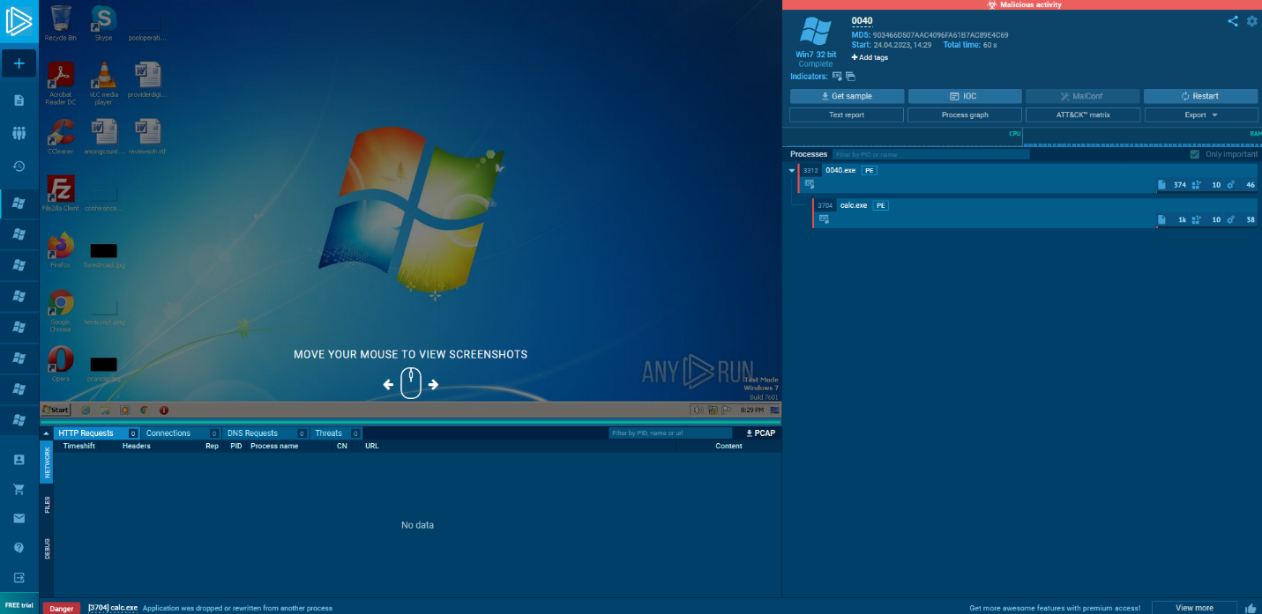

0041 – <https://app.any.run/tasks/96cd75ee-4d8f-49b9-8f5b-f654f9bb02e9>

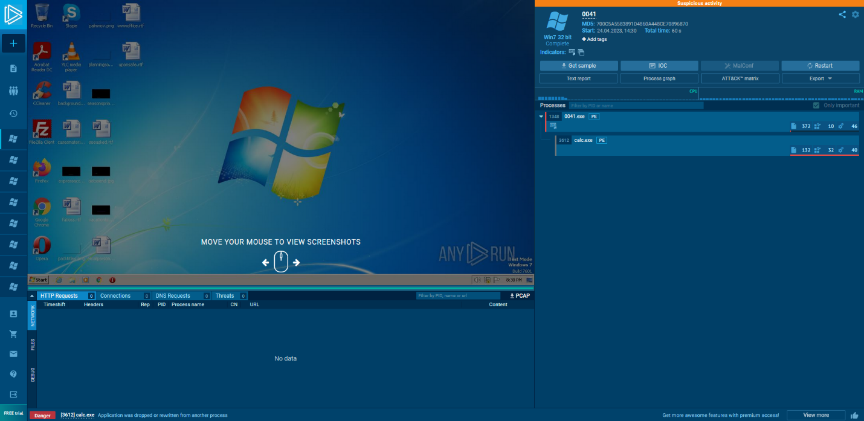

0042 – <https://app.any.run/tasks/b0b22db8-27cc-4690-88f3-52601ef66973>

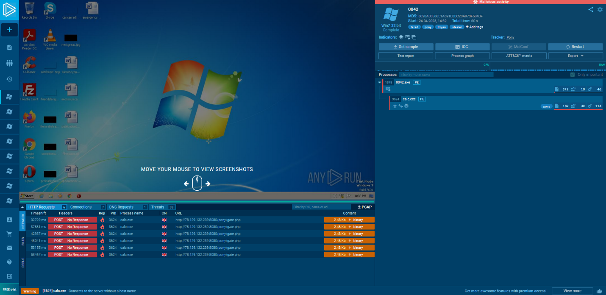

0043 – <https://app.any.run/tasks/2145bca9-7c40-40e5-bfb2-7f9744d6374b>

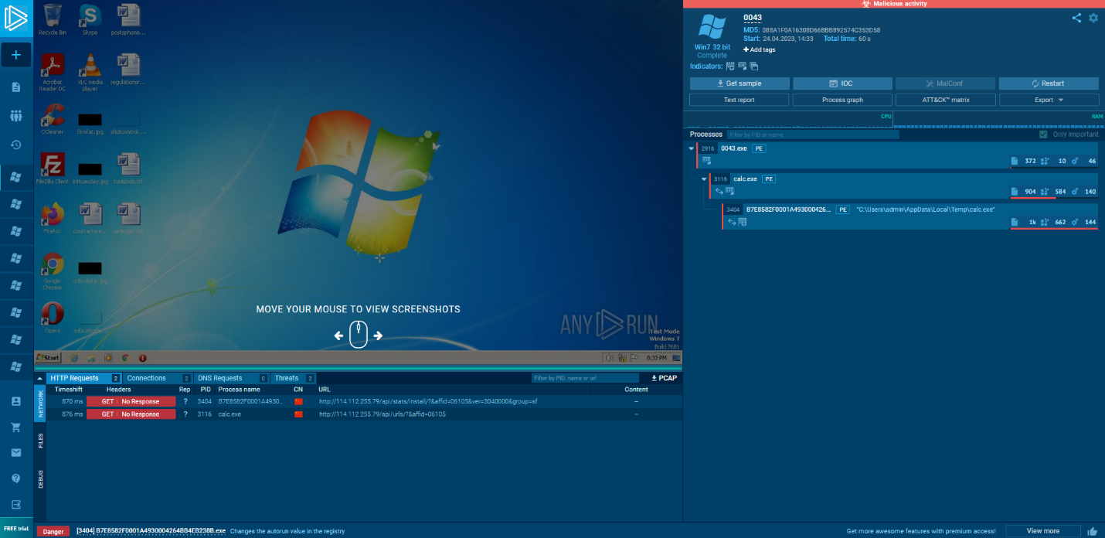

0044 – <https://app.any.run/tasks/bf1997fe-9bff-48b3-9c23-0b1ee2e2d02b>

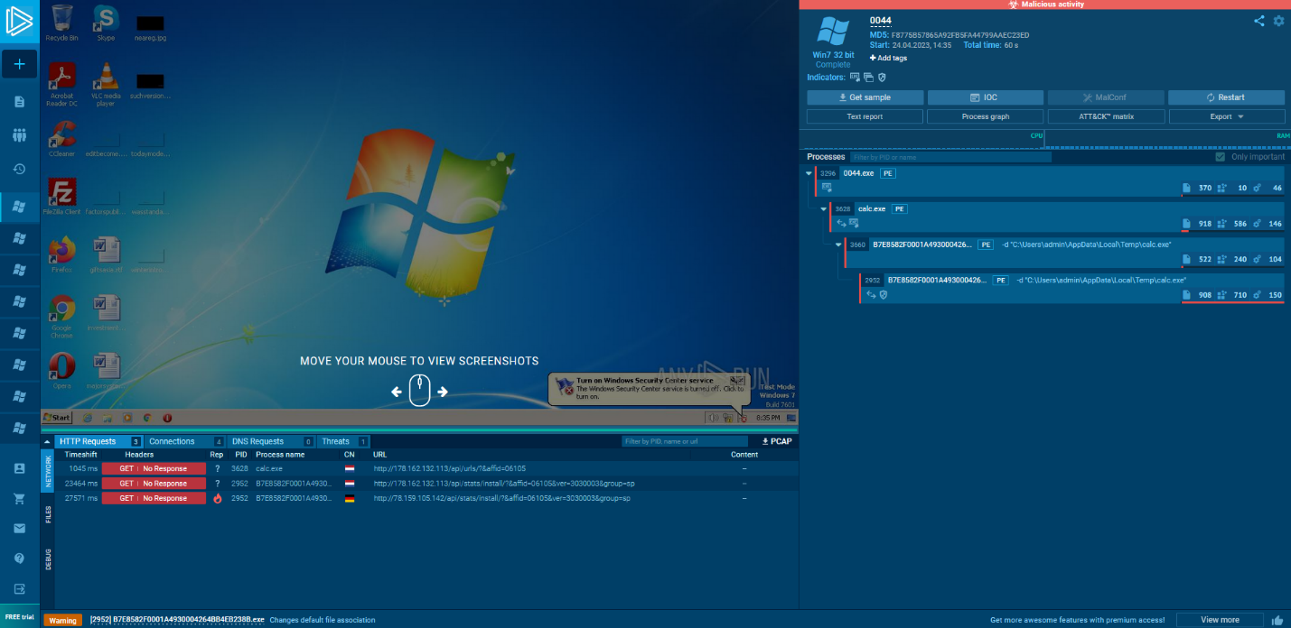

0045 – <https://app.any.run/tasks/7ec02b38-7270-4130-b76c-15de42f6e367>

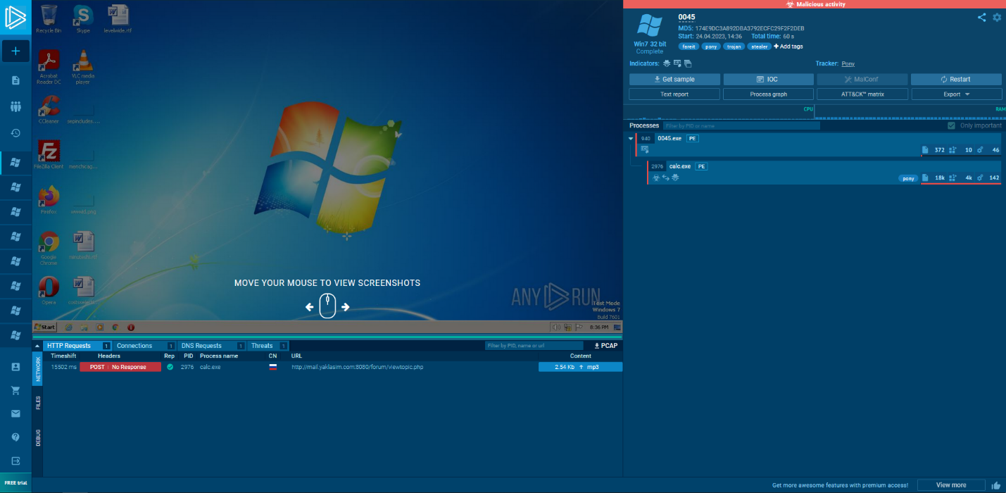

0046 – <https://app.any.run/tasks/b9de2a3e-999e-4889-8287-829004d65ad6>

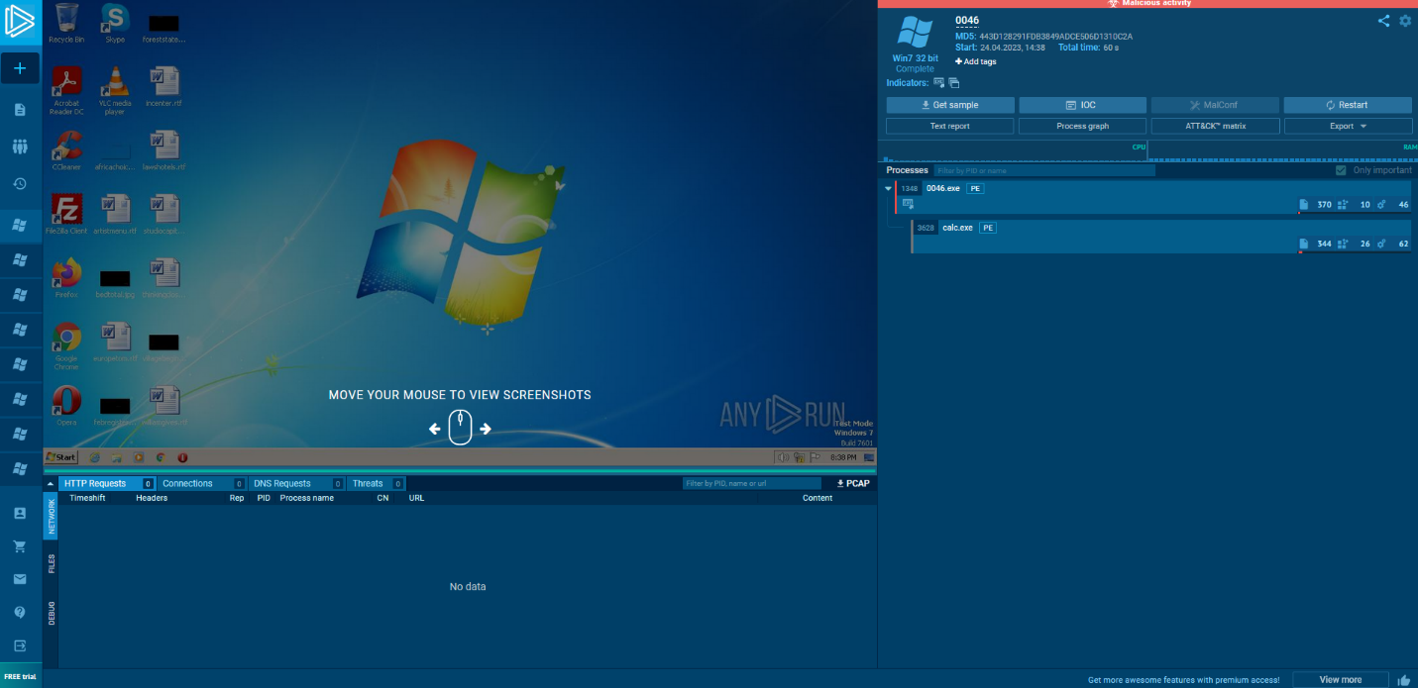

0047 – <https://app.any.run/tasks/98183e5f-f6c5-4086-98e1-e19bf44fafba>

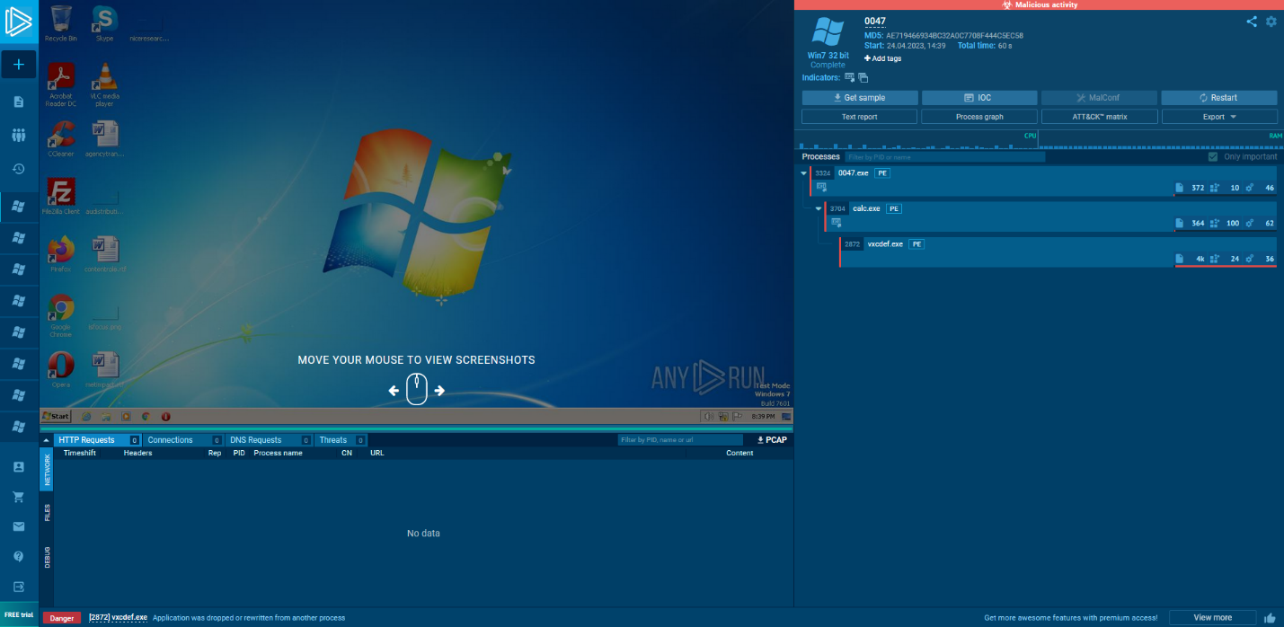

0048 – <https://app.any.run/tasks/019ec546-f63d-45c2-a4e7-4c7904922486>

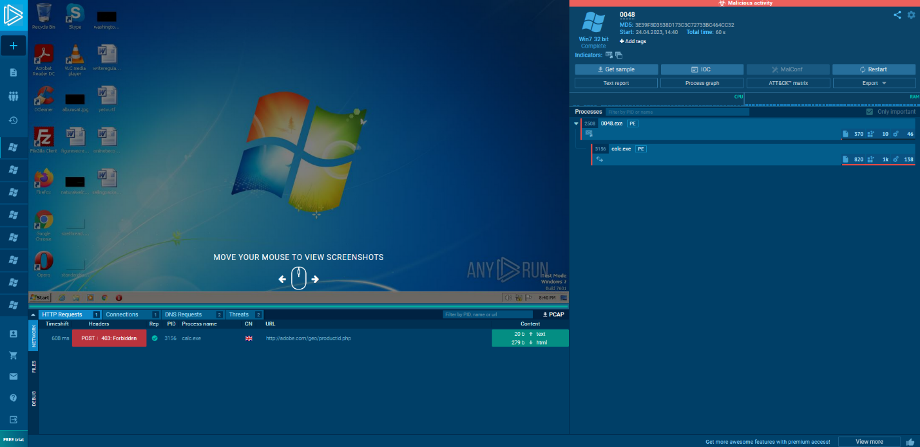

0049 – <https://app.any.run/tasks/b891783b-59dc-40b5-9b88-8d5e927b776c>

